CP to Thinker Check-In Message:
Introduce Herrmann Team Experience

Hello (First Name),

How can we improve our meetings? A question that is often answered with, “Let’s have a meeting to talk about it.” Joking aside, getting your team on the same page is necessary to make your time together more effective. The next stage of the team accelerator tools on Stop & Think awaits your team with the tools you need today!
The Accelerate stage will help your team apply tools to make meetings work - and more. Clarify your goals, create team norms, and help each other Think Big.
Visit the Stop & Think homepage to review the Accelerate stage. Don’t hesitate to pass along questions, and know I am happy to discuss ways we can support your efforts!
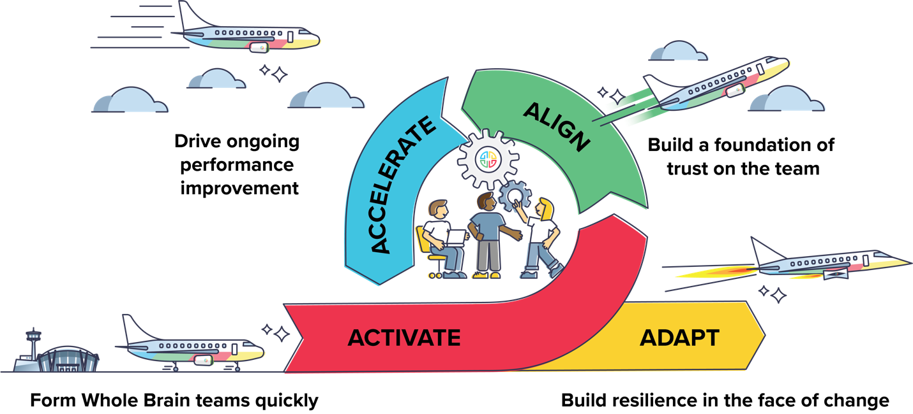

{Sign off}

