CP to Thinker Check-In Message:
Introduce Herrmann Team Experience

Hello (First Name),

Change on a team level often brings uncertainty. A shared flow of work can be disrupted by strategic shifts, staff shuffling, or economic forces outside our control. It is easy to get stuck or frustrated when change becomes a barrier. It is highly effective to be ready to respond.
You have applied the first three stages of the team accelerator tools, and now it is time to learn how to Adapt by applying Whole BrainⓇ tools and resources that are designed to build resilience in your team.
Get started by visiting Stop & Think to plan how you will apply stage four with your team. As always, let me know if I can answer any questions or discuss ways we can support your efforts!
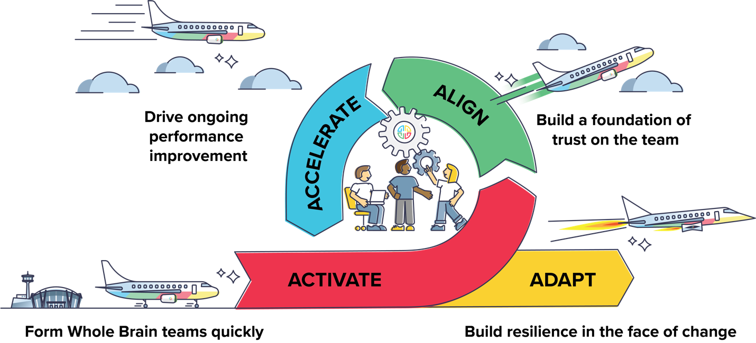

Don’t hesitate to get in touch!
{Sign off}

