**CP to Thinker Check-In Email:**

**Introduce Herrmann Team Experience**

Hello (First Name),

Pushing to meet deadlines during competing priorities. Putting our heads down and grinding out the work. I am sure this sounds familiar, and we all know it is necessary. We also know the downside. Missed opportunities for collaboration, efficiencies left on the table, and frustration with unfocused communication.

You’ve completed stage one of the team accelerator tools. Don’t stop now! Get started on the Align stage to better understand the strengths thinking diversity brings to your team, the collective thinking preferences of your team, and how you can improve your day-to-day communication.   
  
You will also find help organizing your work in the final step - prioritize your goals.   
  
Visit the team accelerator tools on the [Stop & Think](https://herrmann.zendesk.com/hc/en-us/articles/17020792485011-Team-Accelerator-Tools-in-the-Microsoft-Teams-Stop-Think-App) homepage today to plan how your team can continue to build momentum. Let me know if you have any questions or want to discuss ways we can support your efforts!  
  
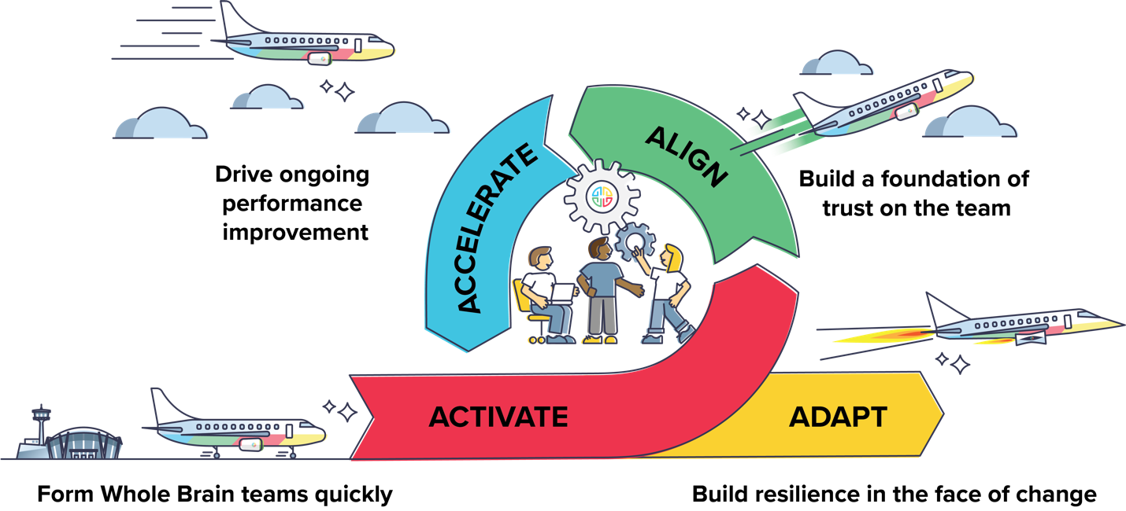

Don’t hesitate to get in touch!  
  
{Sign off}