CP to Thinker Check-In Message:
Introduce Herrmann Team Experience

Hello (First Name),

We all face challenges managing our most important resources, time, and energy. It can be challenging to step into a learning space when there are other business needs that require our attention. The good news? Herrmann's team accelerator tools in Stop & Think can help increase your team's performance!
Getting started is as easy as completing a short survey and finding 15 minutes in your next team meeting. Continuing the journey and increasing your team’s effectiveness is also easy to pick up, as the tools and resources you will find are designed to improve your flow of work.
Herrmann’s team accelerator tools are available on the Stop & Think homepage and ready to help your team activate today. I am happy to answer any questions or discuss how you can set up a plan for your team to tap into your thinking diversity to drive improved performance!
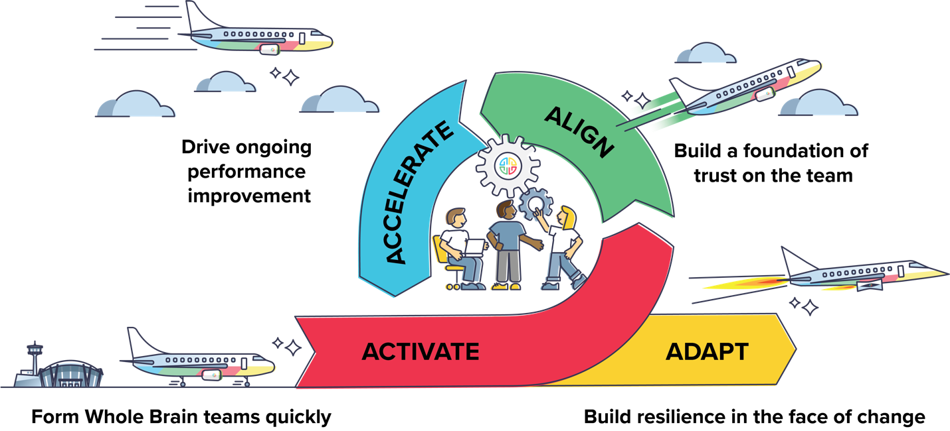

Don’t hesitate to get in touch!
{Sign off}

