CP to Thinker Check-In Message:
Introduce Herrmann Team Experience

Hello (First Name),

Change is inevitable. It is also surprising, even when we see it coming because managing our response is difficult to predict. Navigating change is a process, and by continuing to apply the learning of the team accelerator tools stages, you are ready to explore Whole BrainⓇ Thinking tools that will help your team seize the opportunities change brings.
Get started by visiting Stop & Think to plan how you can apply stage four with your team to start using Whole BrainⓇ tools and resources to build resilience.
As always, let me know if I can answer any questions or discuss ways we can support your efforts!
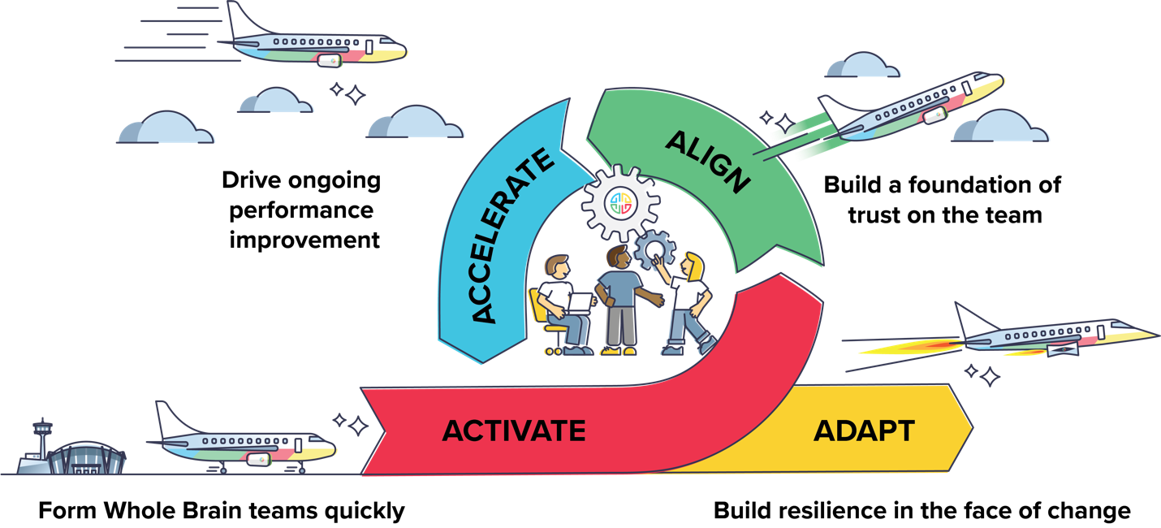

Don’t hesitate to get in touch!
{Sign off}

