**{Subject Placeholder: You’re Just Getting Started! Stage Two Awaits!}**

Hello (First Name),

In a world where communication happens faster than ever, understanding how others think and process information is a key element to meeting the challenges we face. How can our teams make sure our messages are received with the desired intent? By using Whole BrainⓇ Thinking to learn more about the thinking preferences that shape how we experience the word.  
  
You’ve completed stage one of the team accelerator tools. Don’t stop now! Resources to better understand the cognitive diversity of your team and how you can improve your day-to-day communication await!   
  
Additionally, You will also find help organizing your work in the final step - prioritize your goals.   
  
Visit the team accelerator tools in the [Thinker Portal](https://herrmann.zendesk.com/hc/en-us/articles/21225089066643-Team-Accelerator-Tools-in-the-Herrmann-Thinker-Portal) today to plan how your team can continue their journey. Let me know if you have any questions or want to discuss ways we can support your efforts!

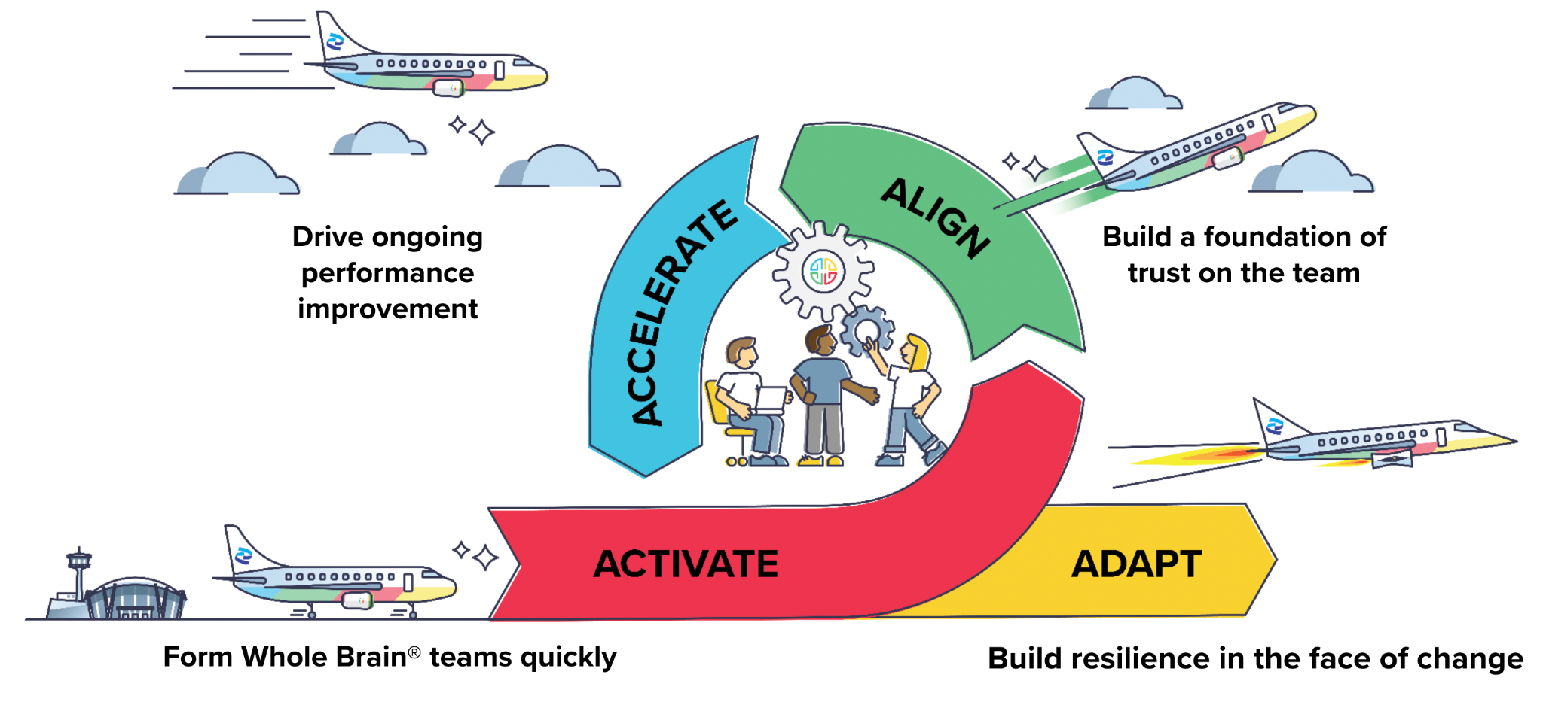

Don’t hesitate to get in touch!  
  
**{Sign off}**