CP to Thinker Check-In Message:
Introduce Herrmann Team Experience

Hello (First Name),

Working teams come in all shapes and sizes. What works best for one might not work for another, yet there is a similar desire - to perform at a high level to achieve exceptional results. How can you learn more about each other and set your sights on a shared vision of high performance?
By introducing everyone to the team accelerator tools in Stop & Think today!
Getting started is as easy as completing a short survey and finding 15 minutes in your next team meeting. Once you have learned more about your team's diverse thinking, you can chart your course for continued learning and application of Whole BrainⓇ Thinking tools and resources.
I am happy to answer any questions or discuss how you can set up a plan for your team to tap into your thinking diversity to drive improved performance!
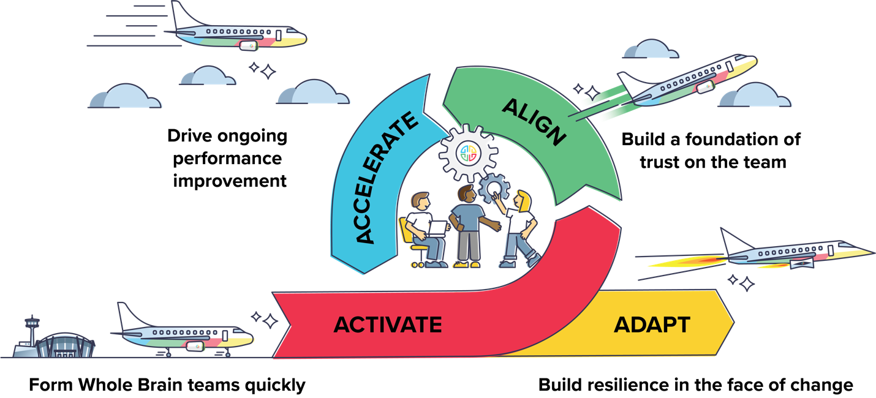

Don’t hesitate to get in touch!
{Sign off}

