**{Subject: Introducing New Team Tools on Herrmann’s Thinker Portal}**

Hello (First Name),

We appreciate all your efforts to apply Whole Brain® Thinking to our work and are excited to announce the roll out of a self-guided learning experience focused on high-performing teams!  
  
Herrmann’s team accelerator tools are now available to all teams on the [Thinker Portal](https://herrmann.zendesk.com/hc/en-us/articles/21225089066643-Team-Accelerator-Tools-in-the-Herrmann-Thinker-Portal). The team accelerator tools use Whole Brain® Thinking resources to go beyond the HBDI® to leverage a team’s cognitive diversity for improved performance outcomes.   
  
Each stage provides resources that are easy to incorporate into your flow of work. You can start at the beginning to build up your effectiveness - or explore the stages with your team to find tools you can apply today!

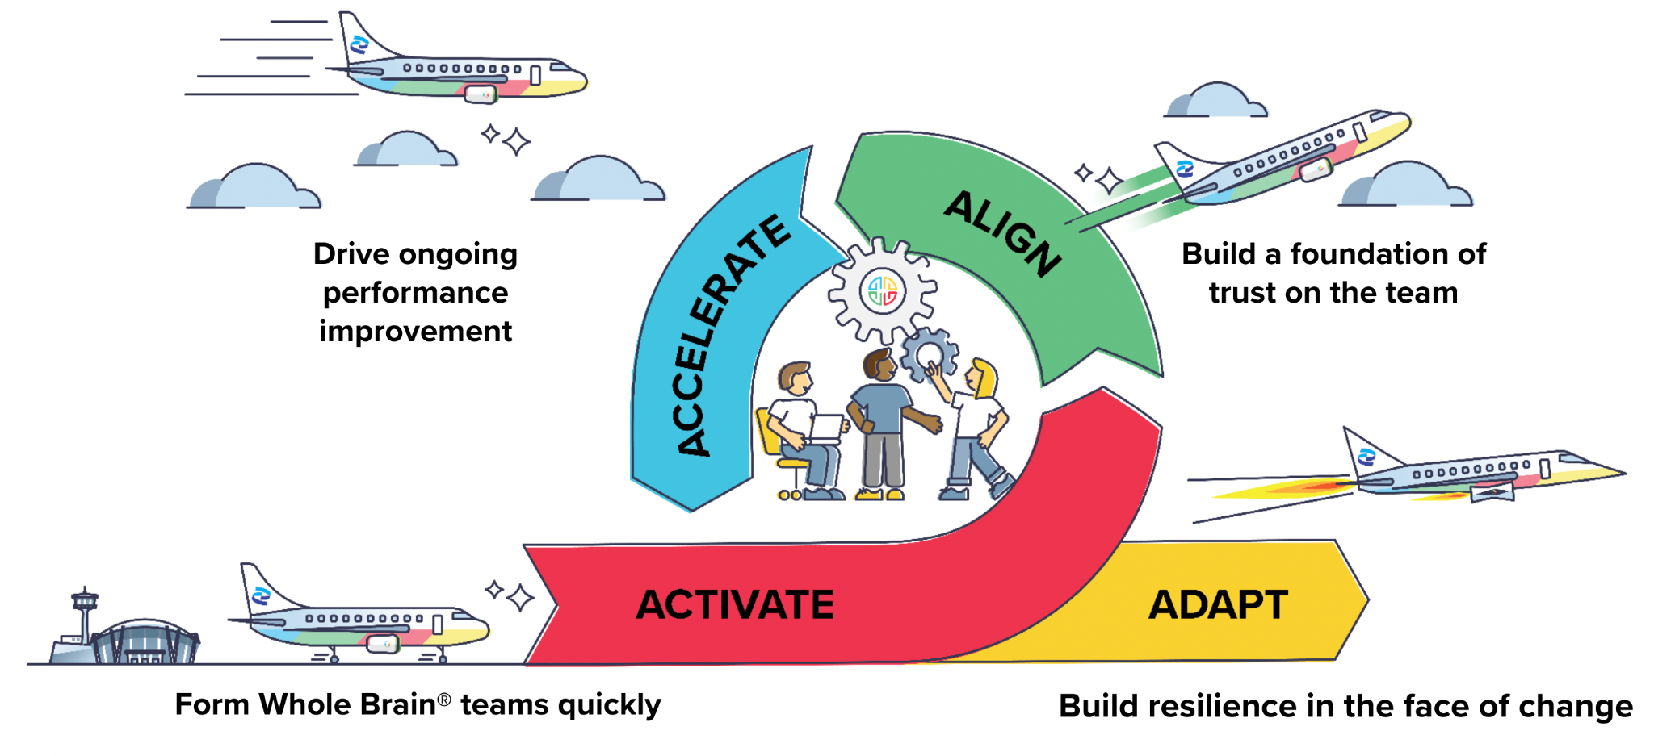

Log in to the Thinker Portal today and review the tools by visiting your team tile and finding “Accelerator Tools” on the top menu! We will also be sharing more information about our roll out process and how our Certified Practitioners will be available to help your team explore the tools.   
  
If you have any questions don’t hesitate to reach out!  
  
**{Sign off}**