**{Subject Placeholder: You’re Activated and Aligned. Get Ready to Accelerate!}**

Hello (First Name),

Bringing our whole brains together to solve problems is crucial to our success. What happens when we find ourselves in meetings that aren’t getting anything done? Frustration, being on the wrong page and stalled projects.

The Accelerate stage of the team accelerator tools gives your team the tools to make meetings work - and more! Clarify your goals, create team norms and help each other Think Big.   
  
To continue building your momentum, visit the [Thinker Portal](https://herrmann.zendesk.com/hc/en-us/articles/21225089066643-Team-Accelerator-Tools-in-the-Herrmann-Thinker-Portal) to review the Accelerate stage. Don’t hesitate to pass along questions and know I am happy to discuss ways we can support your efforts!

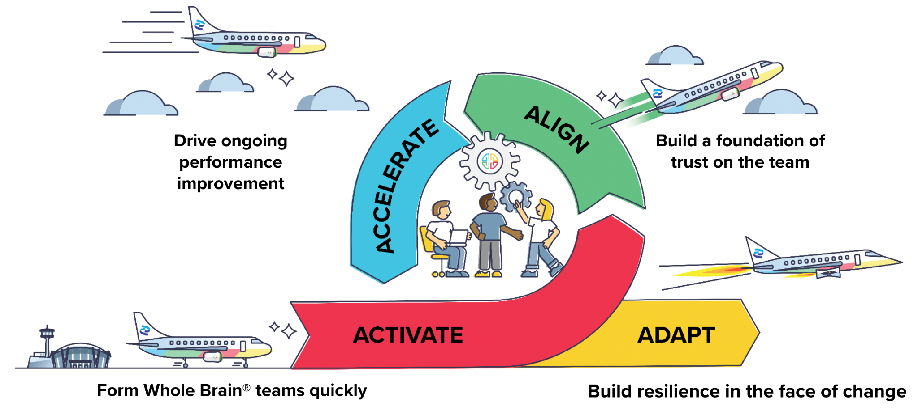

**{Sign off}**