**{Subject Placeholder: You’re Activated and Aligned. Get Ready to Accelerate!}**

Hello (First Name),

“How can we improve our meetings?” is a question that is often answered with, “Let’s have a meeting to talk about it.” Joking aside, getting your team on the same page is necessary to making your time together more effective. The next stage of the team accelerator tools awaits your team with the tools you need today!

The Accelerate stage will help your team apply tools to make meetings work - and more. Clarify your goals, create team norms and help each other Think Big.   
  
Visit the tools in the [Thinker Portal](https://herrmann.zendesk.com/hc/en-us/articles/21225089066643-Team-Accelerator-Tools-in-the-Herrmann-Thinker-Portal) to review the Accelerate stage. Don’t hesitate to pass along questions and know I am happy to discuss ways we can support your efforts!

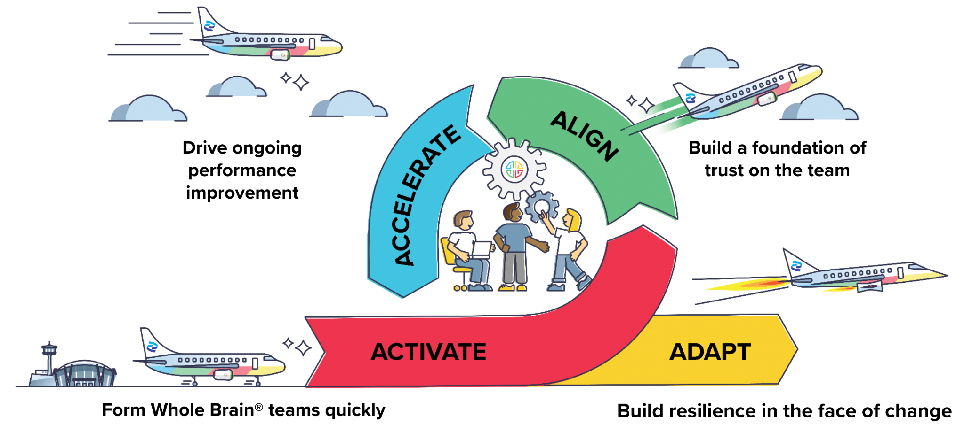

**{Sign off}**