**{Subject Placeholder: Team Accelerator Tools Team Pulse Survey Reminder}**

Hello (First Name),

We are excited for your team to get started with the team accelerator tools! We are sure you will find the activities and tools energizing and engaging as you apply them in your flow of work.

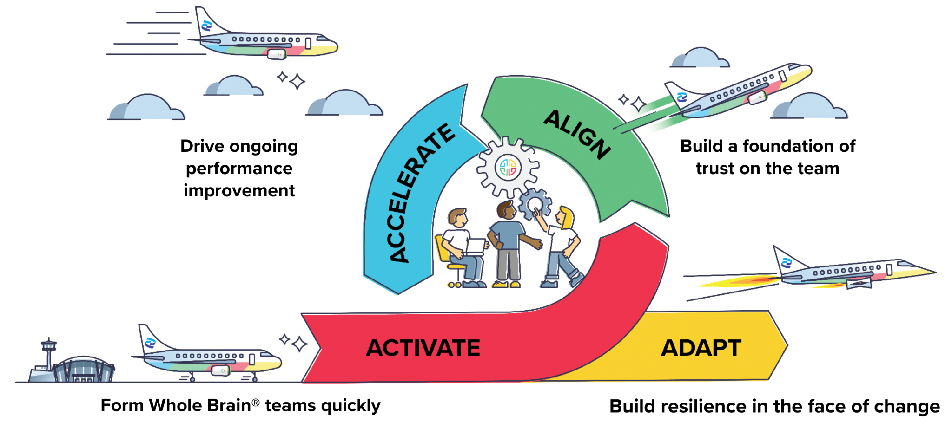

Before you get started, we wanted to provide a quick reminder on the Team Pulse Survey. This survey is the first step of the Activate stage. It is an opportunity for your team to gather baseline data and will be an important assessment point for evaluating your performance.   
  
The short survey can be completed in a few minutes at the start of a meeting, or you can ask your team members to complete the survey on their own the day before you meet to “Share Who You Are”.   
  
Once everyone has completed the survey, I can connect with our Herrmann Representative to get the results. The key pieces of information we need to collect the data are the date the surveys were completed and the team’s name in the Herrmann Platform. The current survey is in a beta stage and as Herrmann communicates improvements to the process, I will be sure to share.  
  
**{Sign off}**