**{Subject Placeholder: Three Down, One to Go!}**

Hello (First Name),

Change is inevitable. It is also surprising, even when we see it coming because managing our response is something that is difficult to predict. Navigating change is a process, and continuing to apply the learning from the stages of the team accelerator tools will help your team seize the opportunities change brings.  
  
Get started by visiting the [Thinker Portal](https://herrmann.zendesk.com/hc/en-us/articles/21225089066643-Team-Accelerator-Tools-in-the-Herrmann-Thinker-Portal) to plan how you can apply stage four with your team to start using Whole BrainⓇ tools and resources to build resilience.   
  
As always, let me know if I can answer any questions or discuss ways we can support your efforts!

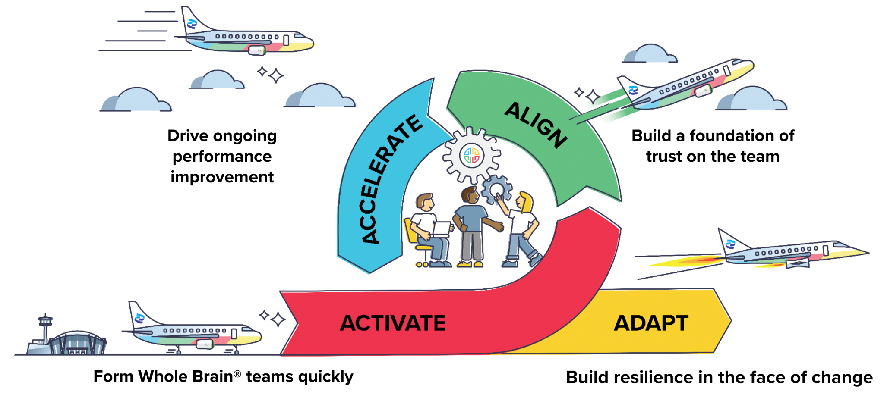

Don’t hesitate to get in touch!  
  
**{Sign off}**