**{Subject Placeholder: Getting Started with Herrmann’s Team Accelerator Tools}**

Hello (First Name),

We all face challenges managing our most important resources - time and energy. It can be tough to step into a learning space when there are other business needs that require our attention. The good news? Herrmann's team accelerator tools in the [Thinker Portal](https://herrmann.zendesk.com/hc/en-us/articles/21225089066643-Team-Accelerator-Tools-in-the-Herrmann-Thinker-Portal) are waiting to help increase the performance of your team!

Getting started is as easy as completing a short survey and finding 15 minutes in your next team meeting. Continuing the journey, and increasing your team’s effectiveness, is also easy to pick up as the tools and resources you will find are designed to improve your flow of work.   
  
Herrmann’s team accelerator tools are ready to help your team activate today. I am happy to answer any questions or discuss how you can set up a plan for your team to tap into your thinking diversity to drive improved performance!

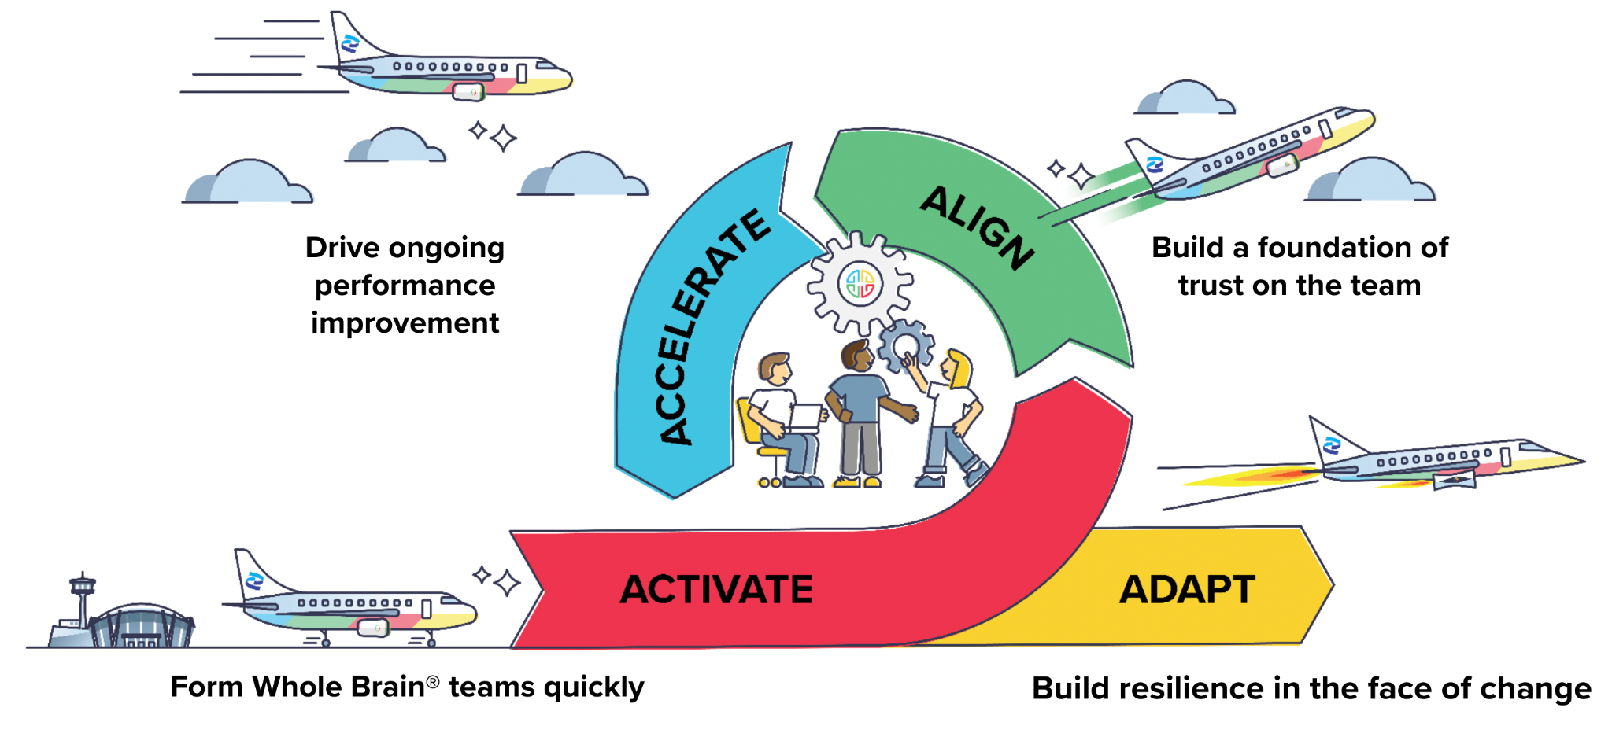

Don’t hesitate to get in touch!  
  
**{Sign off}**