**{Subject Placeholder: Getting Started with Herrmann’s Team Accelerator Tools}**

Hello (First Name),

Working teams come in all shapes and sizes. What works best for one might not work for another, yet there is a similar desire - to perform at a high level to achieve exceptional results. How can you learn more about each other and set your sights on a shared vision of high-performance?  
  
By introducing everyone to the team accelerator tools in the [Thinker Portal](https://herrmann.zendesk.com/hc/en-us/articles/21225089066643-Team-Accelerator-Tools-in-the-Herrmann-Thinker-Portal) today!  
  
Getting started is as easy as completing a short survey and finding 15 minutes in your next team meeting. Once you have gotten to know a little more about the diverse thinking on your team, you can chart your course for continued learning and application of Whole BrainⓇ Thinking tools and resources.   
  
I am happy to answer any questions or discuss how you can set up a plan for your team to tap into your thinking diversity to drive improved performance!

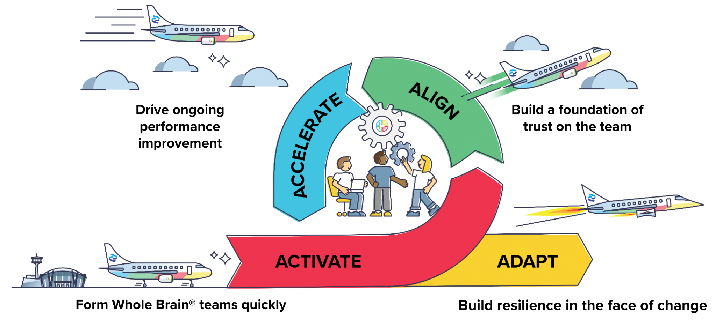

Don’t hesitate to get in touch!  
  
**{Sign off}**